Multivariate Data Analysis : Factor Analysis

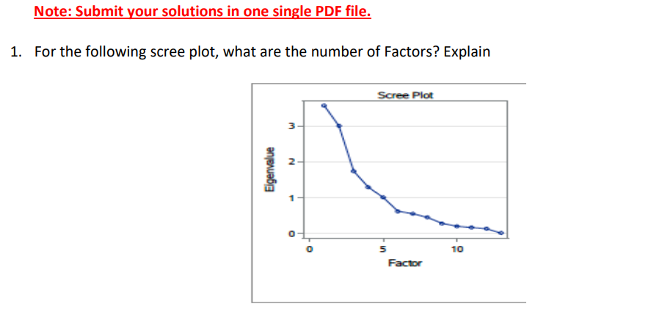

In this analysis, we identify that there are 5 factors based on the examination of a scree plot. A scree plot is a graphical representation used in factor analysis, where the x-axis represents the factors and the y-axis represents eigenvalues. The number of factors is determined by observing the point on the scree plot where the curve levels off or flattens out, indicating the significant factors. This method helps in selecting the appropriate number of factors to consider in the analysis, ensuring meaningful and interpretable results.

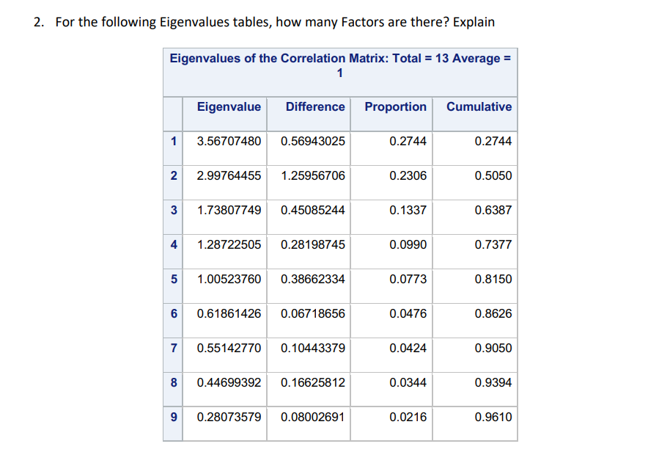

In the correlation matrix provided, we identify 5 factors based on eigenvalues exceeding 1. Eigenvalues represent the variance explained by each factor in factor analysis. By examining the eigenvalues, we can determine the number of meaningful factors to consider in the analysis.

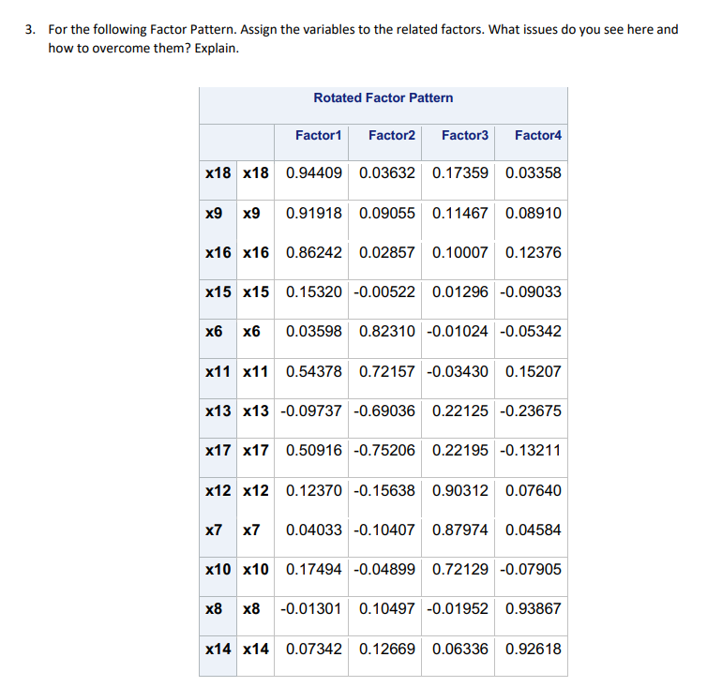

Using a loading value threshold of 0.6, we assigned variables to different factors as follows:

- Factor 1: X18, X9, X16

- Factor 2: X6, X11, X13, X7

- Factor 3: X12, X7, X10

- Factor 4: X8, X14

Variable X15 was not allocated to any factor due to its lack of loading values exceeding 0.6. Consequently, X15 does not make a significant contribution to any of the identified factors based on this loading value threshold. This process of exclusion ensures that only variables strongly associated with specific factors are considered in the analysis, enhancing the clarity and relevance of the factor structure.

4

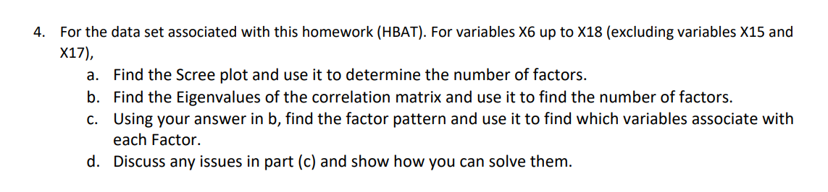.a) 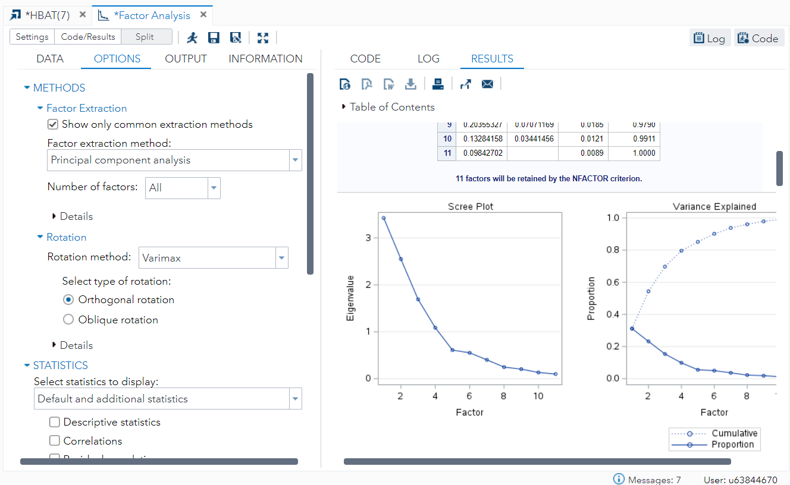

The scree plot suggests that there are 4 factors, as indicated by the point where the graph levels off at the 4th factor.

b) 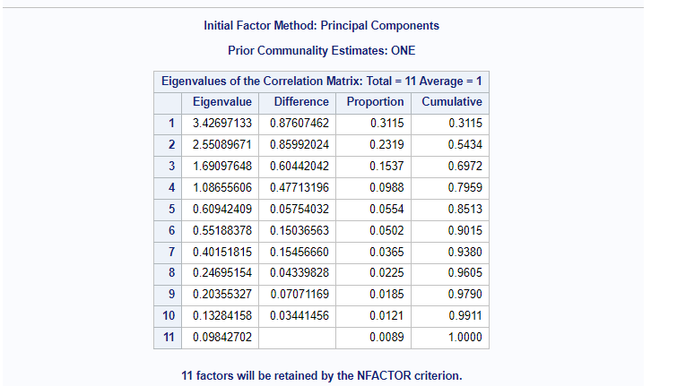

The number of factors will be 4, as indicated by the eigenvalues being above 1 up to the fourth eigenvalue in each row.

c) 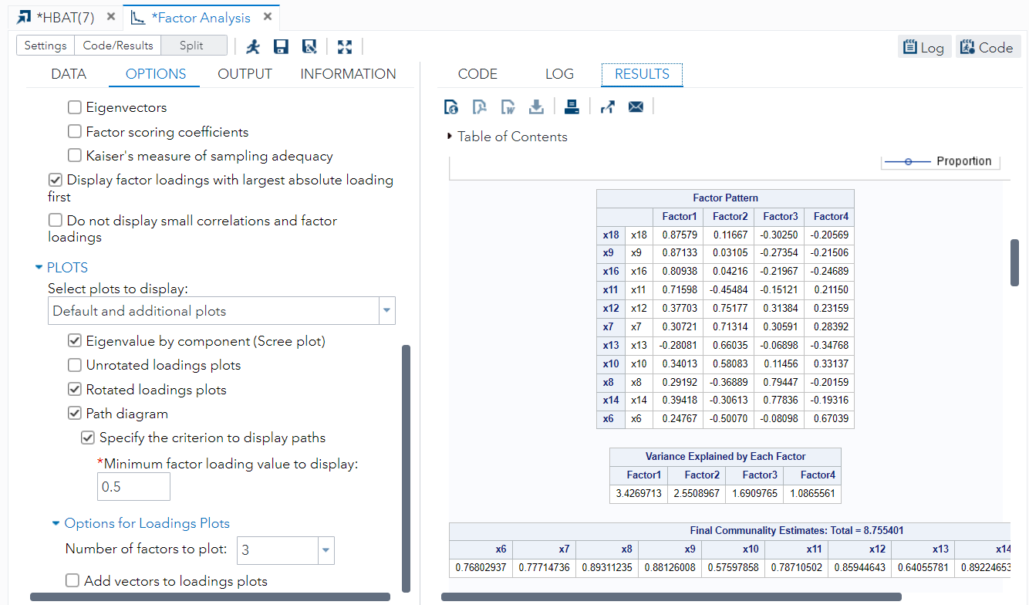

Based on the provided factor pattern:

Factor 1: X18, X9, X16, X11

Factor 2: X12, X7, X13, X10

Factor 3: X8, X14

Factor 4: X6

Each factor represents a set of variables that are closely related or share common underlying factors.

d) 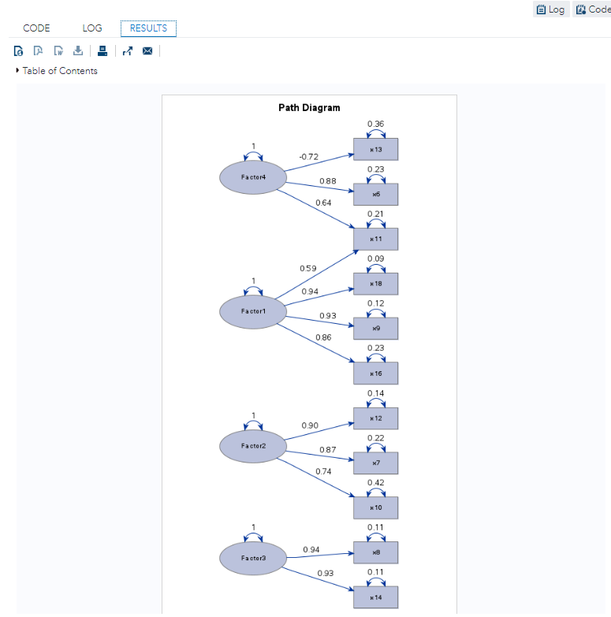 1. X11 being associated with both Factor 4 and Factor 1 indicates a cross-loading problem. In factor analysis, it is generally preferred that each variable is primarily associated with one factor to avoid ambiguity and ensure the interpretability of factors. To resolve this issue, one approach is to remove X11 from the analysis and then rerun the factor analysis to obtain more distinct factor assignments.

2. Factor 3 having only two variables (X8, X14) is less ideal according to typical factor analysis guidelines. Ideally, a factor should have at least three variables to provide a more robust and reliable representation of the underlying construct. However, in certain cases where the relationship between variables is strong and meaningful, accepting two variables for a factor might be considered acceptable, albeit less common.